**Lab3.2: Basic VTP Configuration**

**Topology**

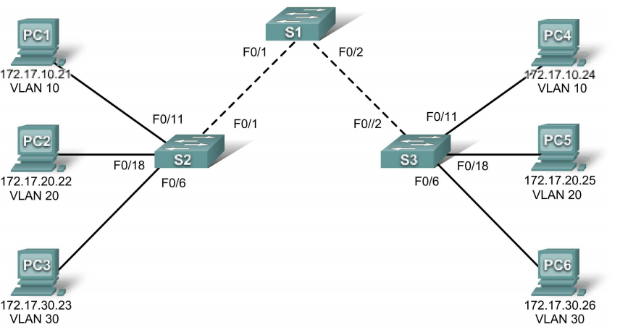

**Addressing table**

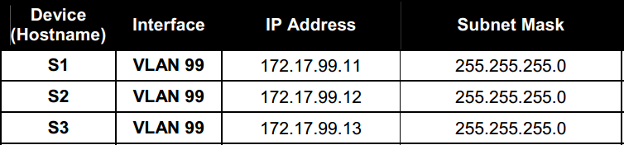

**Initial port assignment**

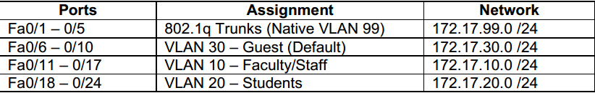

**Task 1: Prepare the Network**  
**Step 1: Cable a network that is similar to the one in the topology diagram.**  
**Step 2: Clear any existing configurations on the switches, and initialize all ports in the shutdown** **state.**  
It is a good practice to disable any unused ports on the switches by putting them in shutdown. Disable all ports on the switches:  
Switch#**config term**  
Switch(config)#**interface range fa0/1-24**  
Switch(config-if-range)#**shutdown**  
Switch(config-if-range)#**interface range gi0/1-2**  
Switch(config-if-range)#**shutdown**

**Task 2: Perform Basic Switch Configurations**  
**Step 1: Configure the switches according to the following guidelines.**  
• Configure the switch hostname.  
• Configure an EXEC mode password of **class**.  
• Configure a password of **cisco** for console connections.  
• Configure a password of **cisco** for vty connections.

**Step 2: Re-enable the user ports on S2 and S3.**  
S2(config)#**interface range fa0/6, fa0/11, fa0/18**  
S2(config-if-range)#**switchport mode access**

S2(config-if-range)#**no shutdown**  
S3(config)#**interface range fa0/6, fa0/11, fa0/18**  
S3(config-if-range)#**switchport mode access**  
S3(config-if-range)#**no shutdown**

**Task 3: Configure and Activate Ethernet Interfaces**  
**Step 1: Configure the PCs.**

**Task 4: Configure VTP on the Switches**  
VTP allows the network administrator to control the instances of VLANs on the network by creating VTP domains*.* Within each VTP domain, one or more switches are configured as VTP servers. VLANs are then created on the VTP server and pushed to the other switches in the domain. Common VTP configuration tasks are setting the operating mode, domain, and password. In this lab, you will be using S1 as the VTP server, with S2 and S3 configured as VTP clients or in VTP transparent mode.  
**Step 1: Check the current VTP settings on the three switches.**  
S1#**show vtp status**

What is the default VTP mode?__________________

**Step 2: Configure the operating mode, domain name, and VTP password on all three switches.**  
Set the VTP domain name to **Lab4** and the VTP password to **cisco** on all three switches**.** Configure S1 in server mode, S2 in client mode, and S3 in transparent mode.  
S1(config)#**vtp mode server**  
Device mode already VTP SERVER.  
S1(config)#**vtp domain Lab4**  
Changing VTP domain name from NULL to Lab4  
S1(config)#**vtp password cisco**  
Setting device VLAN database password to cisco  
S1(config)#**end**  
S2(config)#**vtp mode client**  
Setting device to VTP CLIENT mode  
S2(config)#**vtp domain Lab4**  
Changing VTP domain name from NULL to Lab4  
S2(config)#**vtp password cisco**

Setting device VLAN database password to cisco  
S2(config)#**end**  
S3(config)#**vtp mode transparent**  
Setting device to VTP TRANSPARENT mode.  
S3(config)#**vtp domain Lab4**  
Changing VTP domain name from NULL to Lab4  
S3(config)#**vtp password cisco**

**Step 3: Configure trunking and the native VLAN for the trunking ports on all three switches.**  
Use the **interface range** command in global configuration mode to simplify this task.  
S1(config)#**interface range fa0/1-5**  
S1(config-if-range)#**switchport mode trunk**  
S1(config-if-range)#**switchport trunk native vlan 99**  
S1(config-if-range)#**no shutdown**  
S1(config-if-range)#**end**  
S2(config)# **interface range fa0/1-5**  
S2(config-if-range)#**switchport mode trunk**  
S2(config-if-range)#**switchport trunk native vlan 99**  
S2(config-if-range)#**no shutdown**  
S2(config-if-range)#**end**  
S3(config)# **interface range fa0/1-5**  
S3(config-if-range)#**switchport mode trunk**  
S3(config-if-range)#**switchport trunk native vlan 99**  
S3(config-if-range)#**no shutdown**  
S3(config-if-range)#**end**

**Step 5: Configure VLANs on the VTP server.**  
There are four additional VLANS required in this lab:  
• VLAN 99 (management)  
• VLAN 10 (faculty/staff)  
• VLAN 20 (students)  
• VLAN 30 (guest)  
Configure these on the VTP server.  
S1(config)#**vlan 99**  
S1(config-vlan)#**name management**  
S1(config-vlan)#**exit**  
S1(config)#**vlan 10**  
S1(config-vlan)#**name faculty/staff**  
S1(config-vlan)#**exit**  
S1(config)#**vlan 20**  
S1(config-vlan)#**name students**  
S1(config-vlan)#**exit**  
S1(config)#**vlan 30**  
S1(config-vlan)#**name guest**  
S1(config-vlan)#**exit**  
Verify that the VLANs have been created on S1 with the **show vlan brief** command.  
**Step 6: Check if the VLANs created on S1 have been distributed to S2 and S3.**  
Use the **show vlan brief** command on S2 and S3 to determine if the VTP server has pushed its VLAN configuration to all the switches.  
S2#**show vlan brief**

S3#**show vlan brief**

Are the same VLANs configured on all switches? __________________

**Step 8: Manually configure VLANs.**  
Configure the four VLANs identified in Step 5 on switch S3.  
S3(config)#**vlan 99**  
S3(config-vlan)#**name management**  
S3(config-vlan)#**exit**  
S3(config)#**vlan 10**  
S3(config-vlan)#**name faculty/staff**  
S3(config-vlan)#**exit**

S3(config)#**vlan 20**  
S3(config-vlan)#**name students**  
S3(config-vlan)#**exit**  
S3(config)#**vlan 30**  
S3(config-vlan)#**name guest**  
S3(config-vlan)#**exit**

Here you see one of the advantages of VTP. Manual configuration is tedious and error prone, and any error introduced here could prevent intra-VLAN communication. In addition, these types of errors can be difficult to troubleshoot.  
**Step 9: Configure the management interface address on all three switches.**  
S1(config)#**interface vlan 99**  
S1(config-if)#**ip address 172.17.99.11 255.255.255.0**  
S1(config-if)#**no shutdown**  
S2(config)#**interface vlan 99**  
S2(config-if)#**ip address 172.17.99.12 255.255.255.0**  
S2(config-if)#**no shutdown**  
S3(config)#**interface vlan 99**  
S3(config-if)#**ip address 172.17.99.13 255.255.255.0**  
S3(config-if)#**no shutdown**  
Verify that the switches are correctly configured by pinging between them. From S1, ping the  
management interface on S2 and S3. From S2, ping the management interface on S3.  
Were the pings successful?________________________

**Step 10: Assign switch ports to VLANs.**  
Refer to the port assignment table at the beginning of the lab to assign ports to the VLANs. Use the **interface range** command to simplify this task. Port assignments are not configured through VTP. Port assignments must be configured on each switch manually.The commands are shown for S3 only, but both S2 and S1 switches should be similarly configured. Save the configuration when you are done.  
S3(config)#**interface range fa0/6-10**  
S3(config-if-range)#**switchport access vlan 30**  
S3(config-if-range)#**interface range fa0/11-17**  
S3(config-if-range)#**switchport access vlan 10**  
S3(config-if-range)#**interface range fa0/18-24**  
S3(config-if-range)#**switchport access vlan 20**  
S3(config-if-range)#**end**

**Step 7: Verify that the switches can communicate.**  
From S1, ping the management address on both S2 and S3.  
S1#**ping 172.17.99.12**  
Is the ping attempt successful? _________  
S1#**ping 172.17.99.13**  
Is the ping attempt successful? _________  
**Step 8: Ping several hosts from PC2.**  
Ping from host PC2 to host PC1 (172.17.10.21). Is the ping attempt successful? _________  
Ping from host PC2 to the switch VLAN 99 IP address 172.17.99.12. Is the ping attempt successful?  
_________  
Ping from host PC2 to host PC5. Is the ping attempt successful? _________